Settings
Project Settings is used to configure the project and the number of parameters and features depends on the project type. Examples of Settings page for EEZ-GUI project is shown in Fig. 1.

General
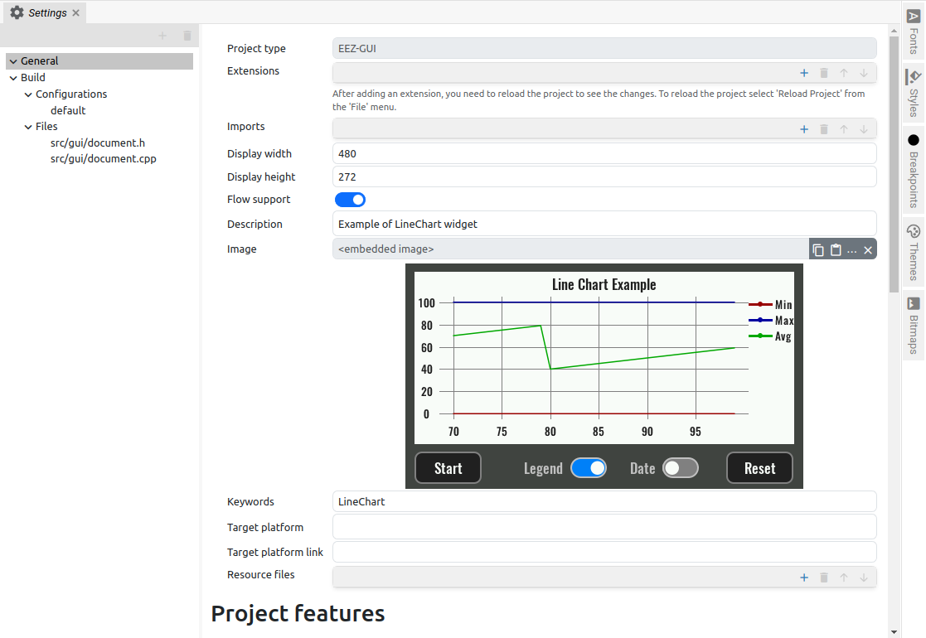Fig. 1: General Project settings (EEZ-GUI)
Item | Description
Project type | Information about the project type. It is generated when creating a new project and cannot be changed later. Supported project types: Dashboard, EEZ-GUI, LVGL, BB3 MicroPython Script and BB3 Applet  (for descriptions see Section P1.1).
Target BB3 firmware (BB3 MicroPython Script only) | Supported versions: 1.7.X or older or 1.8 or newer
Master project (BB3 Applet and BB3 MicroPython Script only) | This is populated when creating a project with the BB3 firmware project name i.e. modular-psu-firmware.eez-project. It can be replaced with a different name and location if needed.
Extensions | List of extensions used by the project. Extensions can be added, deleted and moved in the order in which they will be loaded (Note that the order of loading is not crucial for code execution).
Import | List of external projects used by the project. More info is needed XX.
Title (Dashboard only) | The name of the standalone application or instrument dashboard.
Icon (Dashboard only) | Icon for standalone applications or instrument dashboard.
Display width (EEZ-GUI and LVGL only) | Page width in pixels.
Display height (EEZ-GUI and LVGL only) | Page height in pixels.
Flow support (EEZ-GUI and LVGL only) | Enable the use of EEZ Flow in the project.
Description | Project description shown in the Examples section.
Image | Project screenshot shown in the Examples section.
Keywords | Project keywords shown in the Examples section.
Target platform | Project target platform shown in the Examples section.
Target platform link | Link to the website of the target platform shown in the Examples section.
Author | Project author shown in the Examples section.
Author link | Link to the website of the project author shown in the Examples section.
Min. studio version | Minimum version of EEZ Studio required to run example project. This version will be compared with the version of running Studio and if it is greater then Example will not be shown.
Resource files | List of external files used by Examples. It can be e.g., a .py file used by the Python example (Charts project), or a .csv file used by the CSV example (CSV Project), etc.
Project features | The number of Features depends on the project type. In Fig. 2 are shown for the EEZ-GUI project.

Build
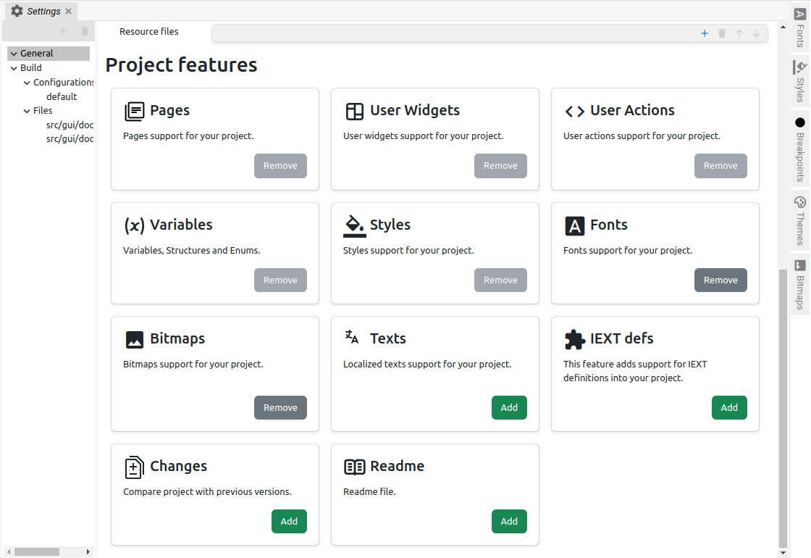Fig. 2: Project features (EEZ-GUI)
The Build subsection is only available for EEZ-GUI and LVGL projects.

Item | Description
Destination folder | The folder in which the build files will be inserted.
LVGL include (LVGL only) | Path to the lvgl.h header file. Normally it is lvgl/lvgl.h, but if it is located somewhere else then it can be specified there.

Configurations
The Configurations subsection is only available for EEZ-GUI projects.

A project can define multiple build configurations. For example, if we use the same project to build native firmware for the hardware board and for the simulator and we do not want to include in the build files for the hardware board resources that are used only for the simulator and vice versa, we will define two configurations.

For Page, Action, SCPI command, Shortcut and Variable, we can indicate in which configuration they are used.

The Used in property (Fig. 3) is used to define in which configuration the item will be used.

Build Configuration parameters are shown in Fig. 4.
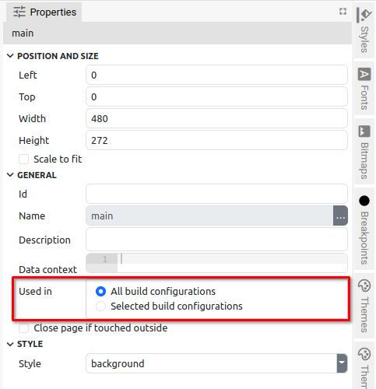Fig. 3: EEZ-GUI project Used in parameter

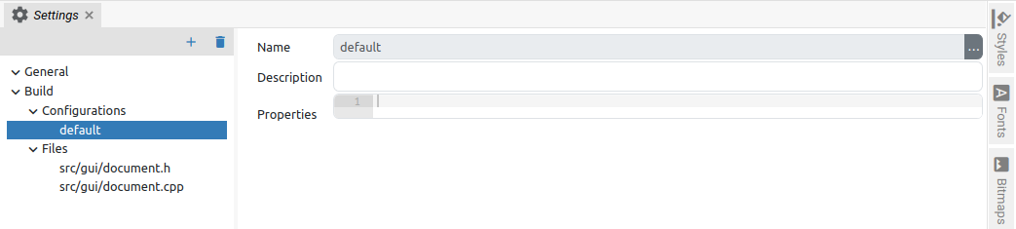Fig. 4: EEZ-GUI build configuration settings
Item | Description
Name | The name of the build configuration.
Description | Description of the build configuration.
Properties | They are used for IEXT to specify additional IEXT options and are defined in JSON format. In the IEXT definition, it is indicated which configuration is used, which is described in Chapter XX.

Files
The Files subsection is only available for EEZ-GUI and LVGL projects. List of template source files from which source files will be generated. This is all already prepared during the creation of the project from the wizard.

